Multi-layer conductive spray coating
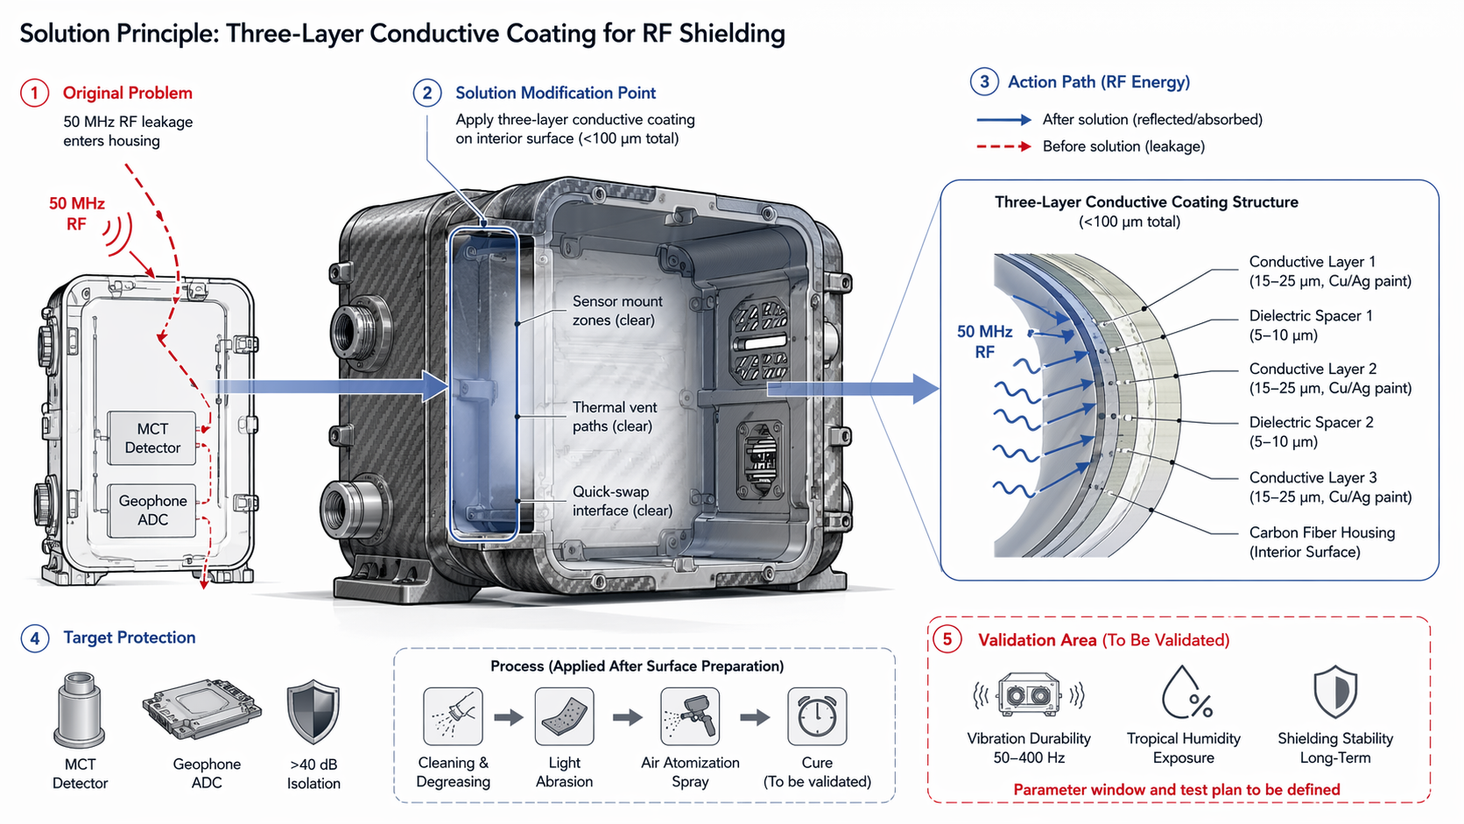

THREE-LAYER CONDUCTIVE COATING FOR RF SHIELDING
Lightweight 50 MHz RF Isolation Solution for Carbon Fiber Housing
Document ID | RF-SHIELD-3L-001
Revision | Rev. A — Draft for Review
Date | 2026-07-10
Classification | Engineering Technical Document

1. EXECUTIVE SUMMARY
This document presents a three-layer conductive coating solution designed to provide >40 dB RF isolation at 50 MHz for a lightweight carbon fiber sensor housing. The coating system—comprising alternating conductive (Cu/Ag-loaded paint) and dielectric layers—is applied to the interior surface via air atomization spray, achieving a total thickness under 100 µm and a mass budget below 0.3 kg. This approach eliminates the 1.5–3 kg mass penalty associated with continuous metal liners while preserving the housing's IP54 thermal management baseline and structural integrity.

2. PROBLEM STATEMENT
The existing carbon fiber composite housing provides inadequate electromagnetic shielding at 50 MHz, the operating frequency of the Ground-Penetrating Radar (GPR) system. Unattenuated RF leakage penetrates the enclosure and couples into sensitive subsystems:
- MCT (Mercury Cadmium Telluride) Detector — susceptible to noise-induced drift and reduced signal-to-noise ratio.
- Geophone ADC — analog-to-digital conversion accuracy degraded by conducted and radiated EMI.
- Target isolation requirement: >40 dB to ensure operational integrity in high-RF environments.
Traditional solutions (e.g., continuous aluminum or copper liners) add 1.5–3 kg of mass, compromise thermal venting, and increase manufacturing complexity. A lightweight, conformal alternative is required.

3. SOLUTION ARCHITECTURE

3.1 Three-Layer Conductive Coating Structure
The proposed solution applies a multi-layer stack to the interior surface of the carbon fiber housing. Each layer is separated by a dielectric spacer, creating multiple impedance mismatch interfaces that reflect and absorb incident RF energy through a combination of skin-effect attenuation and wave interference.
Layer | Material | Thickness | Function
Substrate | Carbon Fiber Composite | — | Structural housing, interior surface
Conductive Layer 1 | Cu/Ag-loaded conductive paint | 15–25 µm | Primary reflection / skin-effect attenuation
Dielectric Spacer 1 | Polymer-based dielectric | 5–10 µm | Impedance mismatch interface
Conductive Layer 2 | Cu/Ag-loaded conductive paint | 15–25 µm | Secondary reflection / absorption
Dielectric Spacer 2 | Polymer-based dielectric | 5–10 µm | Impedance mismatch interface
Conductive Layer 3 | Cu/Ag-loaded conductive paint | 15–25 µm | Tertiary reflection / final attenuation barrier
Total stack thickness: <100 µm | Total added mass: <0.3 kg

3.2 RF Shielding Mechanism
At 50 MHz, the wavelength in free space is approximately 6 m. Inside the conductive coating, the skin depth of copper/silver-loaded paint (effective conductivity ~10⁴–10⁵ S/m) is on the order of tens of micrometers. The three-layer stack operates via two complementary mechanisms:
Reflection Loss: Each conductive–dielectric interface creates an impedance discontinuity (Z₀ ≈ 377 Ω in air vs. Z_metal ≈ 0.01–0.1 Ω). At 50 MHz, the reflection coefficient Γ at each boundary is >0.999, causing multiple internal reflections that trap RF energy within the coating stack.
Absorption Loss: Conductive layers dissipate penetrating RF energy as ohmic heat via the skin effect. With three sequential layers, cumulative absorption exceeds the threshold required for >40 dB isolation across the operational bandwidth.

4. APPLICATION PROCESS

4.1 Surface Preparation
Adhesion and long-term durability of the coating depend critically on substrate preparation. The following steps are performed prior to spray application:
Step 1: Cleaning & Degreasing — Remove mold release agents, oils, and particulate contaminants using isopropyl alcohol or approved solvent wipe.
Step 2: Light Abrasion — Gently abrade the interior carbon fiber surface with fine-grit abrasive pad (e.g., P320–P400) to increase surface energy and mechanical bonding sites. Vacuum debris post-abrasion.
Step 3: Masking — Protect sensor mount zones, thermal vent paths, and quick-swap interface areas with precision-cut masking tape or removable plugs.

4.2 Spray Application (Air Atomization)
The conductive paint is applied using a conventional air-atomization spray gun (HVLP or compliant) under controlled environmental conditions (temperature 20–25 °C, relative humidity 40–60%). Process parameters:
Parameter | Specification
Gun Distance | 150–200 mm from substrate surface
Air Pressure | 1.5–2.5 bar (regulated at gun inlet)
Fluid Flow Rate | 150–250 mL/min
Layer Build Rate | 5–8 µm per pass; flash-off 5–10 min between passes
Dielectric Spacer Application | Spray-applied polymer spacer or pre-cut film lamination; thickness verified by eddy-current or micrometer gauge
Cure cycle: To be validated per paint manufacturer datasheet (typically 24 h ambient or 60 min at 80 °C).

5. DESIGN CONSTRAINTS & CLEARANCES
The coating is applied exclusively to interior surfaces and is engineered to preserve all functional clearances:
• Sensor Mount Zones: Left clear of coating to ensure electrical and thermal interface integrity with MCT detector and geophone ADC modules.
• Thermal Vent Paths: Unobstructed to maintain convective cooling performance and IP54-rated thermal management baseline.
• Quick-Swap Interface: Exposed for tool-less module exchange; coating terminated with a 2 mm margin from interface edges.
• Mass Budget: <0.3 kg total added mass (vs. 1.5–3 kg for metal liner alternative).
• Thermal Mass: Negligible increase; coating specific heat capacity and thickness do not alter thermal time constants.

6. PERFORMANCE SPECIFICATIONS
Parameter | Target | Verification Method
RF Isolation | >40 dB @ 50 MHz | MIL-STD-285 / IEEE 299 shielding effectiveness test
Total Coating Thickness | <100 µm | Eddy-current or cross-sectional microscopy
Added Mass | <0.3 kg | Precision balance (±1 g resolution)
Adhesion Strength | >5B (ASTM D3359) or equivalent | Cross-hatch tape test
Operating Temperature | -20 °C to +60 °C | Environmental chamber cycling

7. VALIDATION & TEST PLAN

7.1 Environmental Durability
Long-term shielding stability under operational and storage conditions requires accelerated life testing. The following test matrix is proposed:
Test | Condition | Duration | Acceptance Criteria
Vibration Durability | 50–400 Hz, 5–20 g RMS random | Per axis, 8 h minimum | No cracking, delamination, or >3 dB shielding degradation
Tropical Humidity | 40 °C / 95% RH | 500 h (IEC 60068-2-78) | No corrosion, blistering, or >3 dB shielding degradation
Thermal Cycling | -20 °C ↔ +60 °C | 100 cycles | No cracking or adhesion loss; shielding stable

7.2 Shielding Effectiveness Verification
Shielding effectiveness (SE) shall be measured per MIL-STD-285 or IEEE 299 using a dual-chamber method. A 50 MHz CW signal is injected into the source chamber; field strength is measured in the receive chamber with and without the coated housing panel installed. SE is calculated as:
SE (dB) = 20 log₁₀(E_without / E_with)

8. RISK ASSESSMENT
Risk | Likelihood | Impact | Mitigation
Adhesion failure under vibration | Medium | High | Optimized surface prep + primer layer; qualification vibration test
Humidity-induced corrosion of conductive layer | Low | Medium | Use Ag-loaded paint (more corrosion-resistant than Cu); conformal coat option
Thickness non-uniformity affecting SE | Medium | Medium | Automated spray robot with real-time thickness monitoring
Dielectric spacer delamination | Low | High | Validated cure cycle; peel strength testing per ASTM D1876

9. CROSS-DOMAIN INTEGRATION
This solution bridges materials science, electromagnetics, and manufacturing engineering:
Materials Science: Selection of conductive filler (Cu vs. Ag) balances cost, conductivity, and corrosion resistance; dielectric spacer chemistry optimized for adhesion to both carbon fiber and metal-filled paint.
Electromagnetics: Layer thickness and conductivity tuned to maximize reflection and absorption at 50 MHz via transmission-line modeling (e.g., CST Studio Suite, ANSYS HFSS).
Manufacturing Engineering: Air atomization spray process scaled from aerospace and automotive EMI coating practices; masking and fixturing designed for batch production.
Systems Engineering: Mass, thermal, and structural budgets reconciled with RF performance requirements; traceability matrix maintained from requirement to verification.

10. REFERENCES
[1] Conductive Coating Spraying Method Based on Lightweight Product — Internal Process Reference Document.
[2] MIL-STD-285, 'Military Standard: Attenuation Measurements for Enclosures, Electromagnetic Shielding, for Electronic Test Purposes.'
[3] IEEE Std 299-2006, 'IEEE Standard Method for Measuring the Effectiveness of Electromagnetic Shielding Enclosures.'
[4] ASTM D3359, 'Standard Test Method for Measuring Adhesion by Tape Test.'
[5] IEC 60068-2-78, 'Environmental Testing — Part 2-78: Tests — Test Cab: Damp Heat, Steady State.'
[6] Schelkunoff, S.A. 'Electromagnetic Waves.' D. Van Nostrand Company, 1943. (Shielding theory foundation)

11. APPENDIX: TECHNICAL CONTRACTIONS & SEGMENTATION

11.1 Technical Contradictions Resolved
• RF Isolation vs. Mass: Traditional metal liners provide isolation but violate the mass budget. The segmented multi-layer coating achieves comparable isolation with <10% of the liner mass.
• Conductivity vs. Thermal Mass: High-conductivity metals add thermal mass. The thin-paint approach adds negligible thermal capacitance while providing sufficient conductivity for skin-effect attenuation.
• Coverage vs. Functional Clearances: Full interior coverage would obstruct mounts and vents. Segmented masking preserves critical zones while coating all RF-leakage pathways.

11.2 Segmentation Strategy
The coating is segmented into functional zones to optimize manufacturability and serviceability:
Primary Shield Zone: Covers all interior walls subject to direct RF illumination; receives full 3-layer stack.
Transition Zone: 2–3 mm margin around sensor mounts and vents; receives 1-layer conductive ground plane to maintain electrical continuity without obstructing function.
Exclusion Zone: Quick-swap interface and external connector faces; uncoated to preserve mechanical tolerances and mating surfaces.

DOCUMENT CONTROL
Prepared By | Engineering Team
Reviewed By | RF / EMI Specialist
Approved By | Chief Engineer
Distribution | Restricted — Engineering & QA
Next Review Date | 2026-10-10 (90 days from issue)



